Order of Service

GATHERING OF GOD’S PEOPLE

Welcome and Announcements

Time of Preparation

Prayer of Adoration & Confession
(Followed by the Lord’s Prayer in unison)
Our Father, who art in heaven, hallowed be Thy name. Thy kingdom come, Thy will be done on earth as it is in heaven. Give us this day our daily bread and forgive us our trespasses, as we forgive those who trespass against us. And lead us not into temptation but deliver us from evil; for Thine is the kingdom, the power, and the glory, forever and ever. AMEN

LISTENING TO GOD’S WORD

Praise Selection: Joy to the World*

Family Time: (Children are invited to attend “The Bridge” following this message)

Message: Rev. Jonathan Tait
Love
Matt 1:18-25

RESPONDING TO GOD’S WORD

Praise Selection: The First Nowell*

Prayers of the People: Rev. Jonathan Tait

PREPARING TO SERVE IN GOD’S WORLD

Praise Selection: Hark the Herald Angels
Sing*

Benediction: Rev. Jonathan Tait

*Please stand as you are able

Offering plates are located just inside the sanctuary doors. Thank you for your faithful stewardship.

Hearing Assistive Devices are available at the back of
the sanctuary

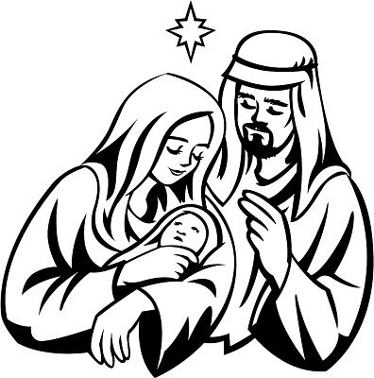

Matthew 1:23
“ “The virgin will conceive and give birth to a son, and they will call him Immanuel”^{[d]} (which means “God with us”).

Living Faith Community Presbyterian Church is a
“Leading With Care” congregation, providing a safe place for children and vulnerable adults according to the requirements of
The Presbyterian Church in Canada.

Announcements
Announcements
Advent of Love

Good morning and welcome. We are so glad that you have chosen to worship with us. Today is the 4th Sunday of Advent, the advent of Love.

Please note that there will not be any Sunday School on December 24th and 31st. We will begin classes again on January 7th.
Rev, Jonathan Tait will be away on holidays beginning December 25th until January 9th
Our church office will be closed between Christmas and New Year’s. Juanita will be back on January 3rd. If you need assistance, please contact your Elder.



Advent
In the fourth candle of Advent shine
our open hearts, both yours and mine.
We can now fill our hearts with love
and shining light from heaven above.
Now we are on the earth
Waiting for the Christ Child’s birth.

ANNOUNCEMENTS Continued

Did you know that you can watch previous sermons on youtube? Just go to youtube.com/LivingFaithBaxterChurch



December
24th - Christmas Eve Service 7pm
31st – Rev. Jim Johnson
January
7th – Rev. Jim Johnson

Prayer Corner
Please keep the following people in your prayers this week Shelly, Bruce, Bill,
Sue, Jasmina, Dave, Rosco, Charlie, Scott Dunn, Julie Henry, Bennett, Lynn and Grace

December Duty Elder: Trace Leonard
If anyone has any announcements, please see the Duty Elder before the service.


Last Week:
Attendance: 108
Offering: $2918.00
Mission: $43.00

Sermon Notes

Weekly at Living Faith
Wednesday: Office 9-1 pm
Bible Study, 1-2:30 pm
You Too Youth, 6:30-8pm
Thursday: Office 9-1 pm
Friday: Office 9-1 pm
Sunday: Worship Service, 10:30 am
Coffee and Fellowship 11:30-12 pm

Pastor: Rev. Jonathan Tait, jwtait1@hotmail.com
Administration: Juanita Borland
Custodian: Peter Gallant



CHURCH CONTACT INFORMATION
Living Faith Community Presbyterian Church
206 Murphy Rd., Baxter, ON, L0M 1B1, ccli# 1142710
Office: (705) 424-0779; e-mail: livingfaithbaxter@gmail.com
www.livingfaithbaxter.com; @LivingFaithPres, youtube.com/LivingFaithBaxterChurch & on facebook

Sunday, December 24, 2023
Welcome to
Living Faith Community
Presbyterian Church
Bringing God's Word to Life,
passionately serving Jesus Christ, each other,
and the community.



4th Sunday of Advent

“Love”



We are blessed to have you here this morning. Please join us after our service today for coffee and fellowship in Celebration Hall.

